**Trabajo Practico**

**Alumno:** Santiago Vietto

**Materia:** Lenguajes Formales y Automatas

Clave: 1802890

**Año:** 2020

**Ejercicio 1:**

**AFND:**

|  |  |  |  |
| --- | --- | --- | --- |
| **f** | **0** | **1** | **λ** |
| >q0 |  | q1 | q6 |
| q1 | q2 | q2,q3 | q5 |
| q2* |  |  |  |
| q3 | q4 |  |  |
| q4 | q2 |  | q5 |
| q5 |  | q3 |  |
| q6 |  | q1 |  |

T = { (q0,q0) , (q0,q6) , (q1,q1) , (q1,q5) , (q2,q2) , (q3,q3) , (q4,q4) , (q4,q5) , (q5,q5) , (q6,q6) }

T’ = { (q0,q0) , (q0,q6) , (q1,q1) , (q1,q5) , (q2,q2) , (q3,q3) , (q4,q4) , (q4,q5) , (q5,q5) , (q6,q6) }

* T = T’ por que no hay transitividad en ningun lado

C0 ≡ q0 λ {q0,q6} = C0

f(C0,0) = { } λ { } = C1

f(C0,1) = q1 λ {q1,q5} = C2

f(C1,0) = { } λ { } = C1

f(C1,1) = { } λ { } = C1

f(C2,0) = q2 λ q2 = C3

f(C2,1) = {q1,q3} λ {q1,q3,q5} = C4

f(C3,0) = { } λ { } = C1

f(C3,1) = { } λ { } = C1

f(C4,0) = {q2,q4} λ {q2,q4,q5} = C5

f(C4,1) = {q1,q3} λ {q1,q3,q5} = C4

f(C5,0) = q2 λ q2 = C3

f(C5,1) = q3 λ q3 = C6

f(C6,0) = q4 λ {q4,q5} = C7

f(C6,1) = { } λ { } = C1

f(C7,0) = q2 λ q2 = C3

f(C7,1) = q3 λ q3 = C6

|  |  |  |
| --- | --- | --- |
| f | 0 | 1 |
| >C0 | C1 | C2 |
| C1 | C1 | C1 |
| C2 | C3 | C4 |
| C3* | C1 | C1 |
| C4 | C5 | C4 |
| C5* | C3 | C6 |
| C6 | C7 | C1 |
| C7 | C3 | C6 |

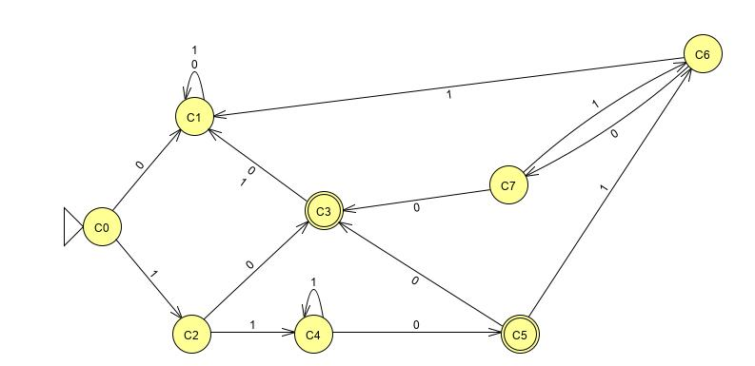**AFD:**

* Es conexo
* Determino las equivalencias:

E0 = {C0,C1,C2,C4,C6,C7} E1 = {C3,C5}

f(C0,0) = C1 ∈ E0

f(C0,1) = C2 ∈ E0

f(C1,0) = C1 ∈ E0

f(C1,1) = C1 ∈ E0

f(C2,0) = C3 ∈ E1

f(C2,1) = C4 ∈ E0

f(C4,0) = C5 ∈ E1

f(C4,1) = C4 ∈ E0

f(C6,0) = C7 ∈ E0

f(C6,1) = C1 ∈ E0

f(C7,0) = C3 ∈ E1

f(C7,1) = C6 ∈ E0

C0 ≡ C1 ≡ C6 C2 ≡ C4 ≡ C7

f(C3,0) = C1 ∈ E0

f(C3,1) = C1 ∈ E0

f(C5,0) = C3 ∈ E1

f(C5,1) = C6 ∈ E0

C3 ≠ C5

f(C0,0) = C1 ∈ E0

f(C0,1) = C2 ∈ E1

f(C1,0) = C1 ∈ E0

f(C1,1) = C1 ∈ E0

f(C6,0) = C7 ∈ E1

f(C6,1) = C1 ∈ E0

C0 ≠ C1 ≠ C6

f(C2,0) = C3 ∈ E2

f(C2,1) = C4 ∈ E1

f(C4,0) = C5 ∈ E3

f(C4,1) = C4 ∈ E1

f(C7,0) = C3 ∈ E2

f(C7,1) = C6 ∈ E0

C2 ≠ C4 ≠ C7

E0 = {C0,C1,C6} E1 = {C2,C4,C7} E2 = {C3} E3 = {C5}

* No se encontraron equivalencias por lo tanto el autómata ya es mínimo.

AFD = ( {0,1} , {C0,C1,C2,C3,C4,C5,C7 } , C0 , f , {C3,C5} )

**Ejercicio 2:**

A)_

**AFND:**

|  |  |  |  |  |
| --- | --- | --- | --- | --- |
| **f** | **a** | **b** | **c** | **λ** |
| >p | p | q | r |  |
| q | q | r |  | p |
| r* | r |  | p | q |

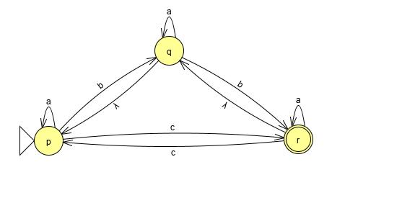

T = { (p,p) , (q,q) , (q,p) , (r,r) , (r,q) }

T’ = { (p,p) , (q,q) , (q,p) , (r,r) , (r,q) , (r,p) }

C0 ≡ p λ {p} = C0

f(C0,a) = p λ {p} = C0

f(C0,b) = q λ {p,q} = C1

f(C0,c) = r λ {p,q,r} = C2

f(C1,a) = {p,q} λ {p,q} = C1

f(C1,b) = {q,r} λ {p,q,r} = C2

f(C1,c) = r λ {p,q,r} = C2

f(C2,a) = {p,q,r} λ {p,q,r} = C2

f(C2,b) = {q,r} λ {p,q,r} = C2

f(C2,c) = {r,p} λ {p,q,r} = C2

|  |  |  |  |
| --- | --- | --- | --- |
| **f** | **a** | **b** | **c** |
| >C0 | C0 | C1 | C2 |
| C1 | C1 | C2 | C2 |
| C2* | C2 | C2 | C2 |

**AFD:**

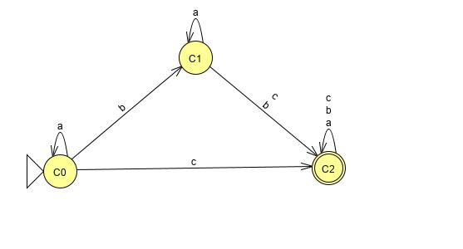

* Es conexo
* Determino las equivalencias:

E0 = {C0,C1} E1 = {C2}

f(C0,a) = C0 ∈ E0

f(C0,b) = C1 ∈ E0

f(C0,c) = C2 ∈ E1

f(C1,a) = C1 ∈ E0

f(C1,b) = C2 ∈ E1

f(C1,c) = C2 ∈ E1

C0 ≠ C1

* No se encontraron equivalencias por lo tanto el autómata ya es mínimo.

AFD = ( {a,b,c} , {C0,C1,C2} , C0 , f , C2 )

B)_

**AFND:**

|  |  |  |  |  |
| --- | --- | --- | --- | --- |
| **f** | **a** | **b** | **c** | **λ** |
| >p |  | q | r | { q , r } |
| q | p | r | { p , q } |  |
| r* |  |  |  |  |

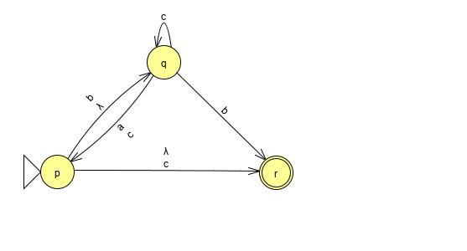

T = T’ = { (p,p) , (p,q) , (p,r) , (q,q) , (r,r) }

* No hay transitividad

C0 ≡ p λ {p,q,r}

f(C0,a) = p λ {p,q,r} = C0

f(C0,b) = {q,r} λ {q,r} = C1

f(C0,c) = {p,q,r} λ {p,q,r} = C0

f(C1,a) = p λ {p,q,r} = C0

f(C1,b) = r λ r = C2

f(C1,c) = {p,q} λ {p,q,r} = C0

f(C2,a) = { } λ { } = C3

f(C2,b) = { } λ { } = C3

f(C2,c) = { } λ { } = C3

f(C3,a) = { } λ { } = C3

f(C3,b) = { } λ { } = C3

f(C3,c) = { } λ { } = C3

|  |  |  |  |
| --- | --- | --- | --- |
| **f** | **a** | **b** | **c** |
| >C0* | C0 | C1 | C0 |
| C1* | C0 | C2 | C0 |
| C2* | C3 | C3 | C3 |
| C3 | C3 | C3 | C3 |

**AFD:**

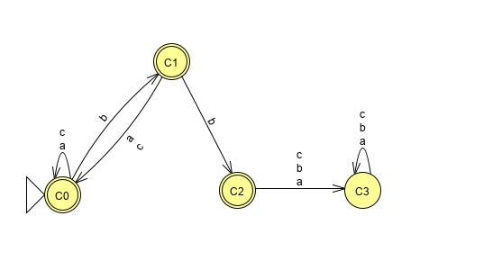

* Es conexo
* Determino las equivalencias:

E0 = {C3} E1 = {C0,C1,C2}

f(C0,a) = C0 ∈ E1

f(C0,b) = C1 ∈ E1

f(C0,c) = C0 ∈ E1

f(C1,a) = C0 ∈ E1

f(C1,b) = C2 ∈ E1

f(C1,c) = C0 ∈ E1

f(C2,a) = C3 ∈ E0

f(C2,b) = C3 ∈ E0

f(C2,c) = C3 ∈ E0

C0 ≡ C1

E0 = {C3} E1 = {C0,C1} E2 = {C2}

f(C0,a) = C0 ∈ E1

f(C0,b) = C1 ∈ E1

f(C0,c) = C0 ∈ E1

f(C1,a) = C0 ∈ E1

f(C1,b) = C2 ∈ E2

f(C1,c) = C0 ∈ E1

C0 ≠ C1 ≠ C2

* No se encontraron equivalencias por lo tanto el autómata ya es mínimo.

AFD = ( {a,b,c} , {C0,C1,C2,C3} , C0 , f , {C0,C1,C2} )